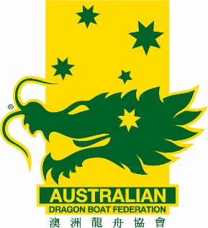
AusChamps Entry Cancellation & Refund Form
Submit to: info@ausdbf.com.au
AusDBF Account Details
BSB: 013132 Acc: 294 013 586
Refer Memo # 007

Club Name:

List entry/s requesting refund for:
e.g. standard boat premier mixed 200m
Standard Boat | Small Boat
Total refund amount requested:
Transaction Date: | Receipt No:

Include reason for withdrawing entry and requesting refund:

Request submitted by:
Club contact:
Mobile: | Email:
Signature: | Date:
Club BSB: | Club Account Number:
Note: Please include club account details to allow refund to be processed promptly

Entry cancellation confirmed by:
Business Services Name): | Date:
Signature:

Entry Refund approved and processed by:
AusDBF Accounts (Name): | Amount paid:
Signature: | Date paid:

