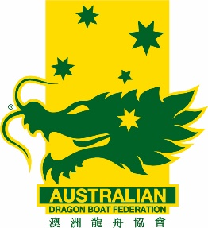
AusChamps / CCWC Exemption Application
Request Form
AusDBF Account Details
BSB: 013132 Acc: 294 013 586

Exemptions will only be considered once this form has been fully completed and approved by the Member State. Emails, non-complete forms and forms not approved by the AusDBF Member will be returned and not considered.

Forms to be submitted to info@ausdbf.com.au minimum 30 days prior to AusChamps. Any requests received after this time may not be considered.

Exemption requests must be accompanied by a $20 non-refundable deposit
Transaction Date: |  | Receipt no:

Name of event:

Name of Club:

Name of paddler: | Division/Category:

Tick which best reflects exemption request
Sweep: | Drummer: | Paddler:

Reason for exemption Request. Clubs must provide all relevant information with regards to the make-up for the crew. Providing minimal information may hold up approval consideration process.

Include rule number exemption request relates to (AusDBF Rules or IDBF Rules & Competition Regulations)

Name of authorised Club representative submitting request: | Signature: Date:
Mobile number: | Email:

State Association Approval
Name: | Signature: Date:
Comment / Support from State:

